Project Report: Library Management & Resource Allocation System

NAME-KHUSBOO PRADHAN
REGISTRATION NO.-25BAI11068
COURSE TITLE-PROGRAMMING IN JAVA
FACULTY NAME- DR. DHEERESH SONI
PROJECT TITLE-”LIBRARY MANAGEMENT & RESOURCE ALLOCATION SYSTEM”

INTRODUCTION
The Library Management System is a modular Java application designed to demonstrate object-oriented design principles, custom exception handling, thread concurrency, and priority-driven resource scheduling. Unlike traditional GUI-based applications, this system runs in a lightweight console environment, emphasizing execution speed, maintainability, and resource efficiency.

PROBLEM STATEMENT
Educational libraries frequently experience high demand for physical and digital resources. Traditional simple allocation systems fail to address two critical operational bottlenecks:
- Priority Scheduling: Faculty and research scholars are often delayed by first-come, first-served reservation queues.
- Concurrent Digital Access: Concurrent requests for limited digital resource licenses can lead to race conditions and over-allocation.
This project addresses these issues by implementing custom priority-based reservation queues and thread-safe concurrent digital licensing mechanisms.

FUNCTIONAL REQUIREMENTS
- Resource Categorization: Support for both physical books and digital resources under a shared resource interface.
- Priority-Based Reservation: Priority queue processing that prioritizes faculty members over student requests.
- Concurrent Digital Licensing: Multi-threaded checkout management ensuring digital access limits are strictly enforced.
- Exception Management: Custom exception handling for unavailable resources and invalid operations.

NON FUNCTIONAL REQUIREMENTS

- Reliability: Robust handling of runtime edge cases using custom exceptions.
- Performance & Efficiency: Low memory footprint running natively within terminal environments without GUI framework overhead.
- Maintainability: Highly modular class hierarchy allowing easy expansion of resource types.
- Concurrency Control: Thread-safe synchronization preventing race conditions during resource checkouts.

SYSTEM ARCHITECTURE
1. System Layer Overview
- - Domain Layer: Abstract Resource class extended by Book and DigitalResource, alongside Member for user roles.
- - Logic Layer: Reservation for priority queues and LibraryException for custom error handling.
- - Execution Layer: Main class managing test execution and thread concurrency.
2. Architectural Features
- Pure Terminal Model: Runs via standard javac and java commands without GUI overhead.
- - Thread Safety: Uses synchronized blocks in DigitalResource to prevent race conditions.
- - Custom Exception Handling: Isolates errors using LibraryException without crashing the system.

DESIGN DIAGRAMS:-
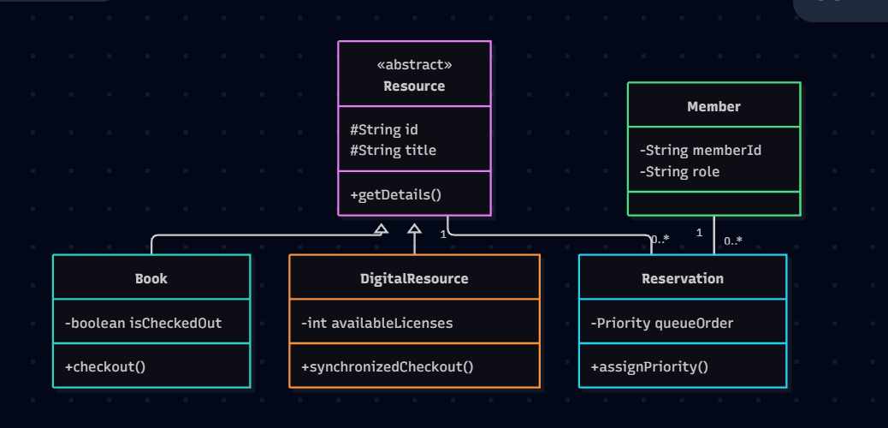
CLASS DIAGRAM

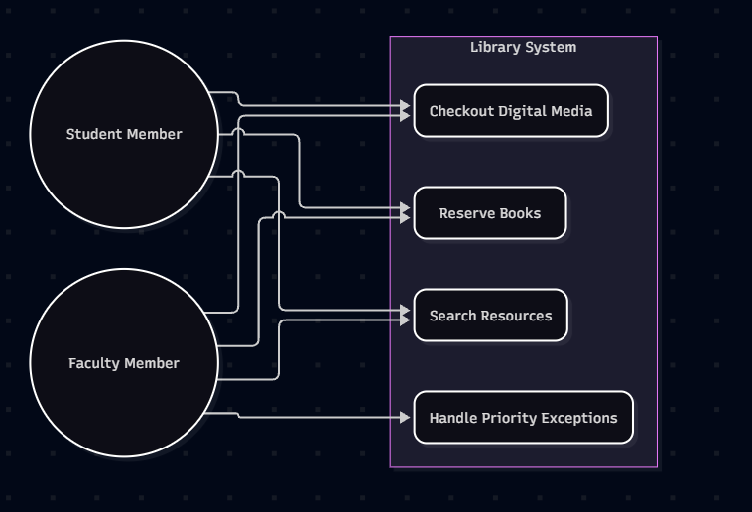
USE CASE DIAGRAM
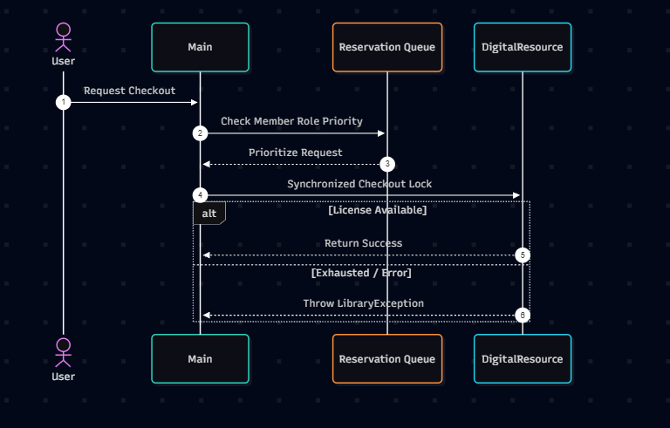
SEQUENCE DIAGRAM
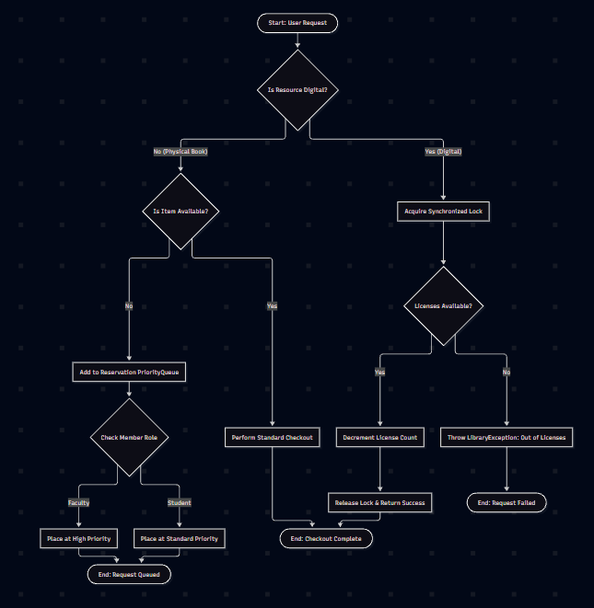
WORKFLOW
DESIGN DECISIONS & RATIONALE
- Console Terminal Architecture: Chosen over GUI to maintain zero external dependencies, fast boot times, and cross-platform terminal execution compatibility.
- Custom Priority Handling: Used Java data structures to ensure faculty priority over standard member roles natively.
- Thread Synchronization: Used explicit synchronization locks within DigitalResource rather than external databases to guarantee thread safety natively.

IMPLEMENTATION DETAILS
1.Key Class Responsibilities
- Resource / Book / DigitalResource: Base model and specific trackers for physical books and thread-safe digital media.
- Member: Holds user profiles and role hierarchy (Faculty vs. Student).
- Reservation: Handles priority queue sorting to rank Faculty requests first.
- LibraryException: Custom exception module for handling runtime errors cleanly.
- Main: Driver program executing tests and multi-threaded concurrency checks.
2.Key Technical Mechanics
- Priority Allocation: Uses role comparisons to jump Faculty to the front of resource queues.
- Concurrency & Locks: Employs synchronized blocks in DigitalResource to prevent race conditions.
- Error Handling: Intercepts bad requests with LibraryException without terminating execution.

SCREENSHOTS/RESULTS
Figure 1: Terminal Execution and Output
* Displays successful compilation using javac *.java and execution via java Main.
* Demonstrates Priority Queue ordering, automatically placing Faculty ahead of Student requests.
* Validates thread-safe Digital Licensing concurrency and session lock management.
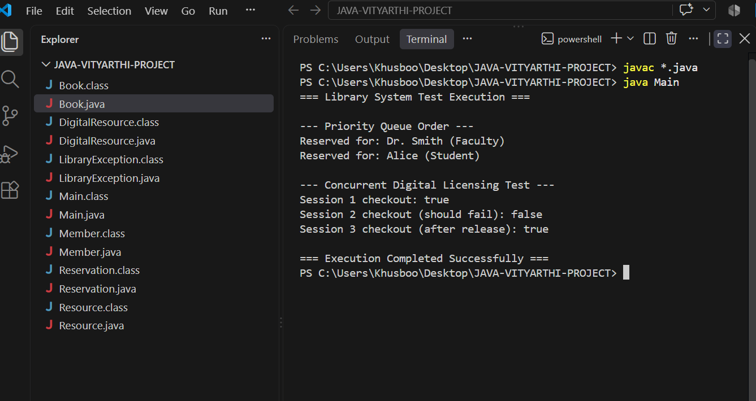
FIGURE 1

TESTING APPROACH
1. Testing Methodologies
- Unit Testing
- Tested individual methods across Resource, Member, and Reservation classes.
- Verified correct attribute initialization and state updates.
- Integration Testing
- Validated smooth interaction between Reservation priority queues and Member role logic.
- Confirmed custom LibraryException triggers properly during invalid operations.
- Concurrency & Thread-Safety Testing
- Simulated multiple simultaneous checkout sessions on DigitalResource objects.
- Verified synchronized blocks prevent race conditions and over-allocation.

2. Test Cases & Execution Results
- Priority Ordering Test: Verified Faculty requests automatically precede Student requests in queue.
- License Limit Test: Verified additional checkout attempts fail safely once digital licenses are exhausted.
- Exception Handling Test: Confirmed invalid item requests return clean status messages without crashing the runtime.

CHALLENGES FACED:
1. Priority Synchronization in Queue Operations
- Challenge: Standard queue implementation caused race conditions when re-ordering Faculty requests over Student requests.
- Solution: Implemented synchronized priority evaluation within Reservation logic to ensure atomic queue updates.

2. Concurrency Control in Digital Licensing
- Challenge: Concurrent access threads caused over-allocation of digital licenses past maximum thresholds.
- Solution: Integrated explicit synchronized blocks inside DigitalResource methods to serialize checkout requests.

3.Exception Propagation Across Layers
- Challenge: Standard Java exceptions interrupted full system test execution and terminated terminal output prematurely.
- Solution: Created custom LibraryException module to catch, log, and isolate runtime errors cleanly without stopping execution

LEARNING & KEY TAKEAWAYS:
1. Core Technical Insights
- Object-Oriented System Architecture: Gained practical experience in applying inheritance, abstraction, and encapsulation using pure Java.
- Thread Synchronization Mechanics: Learned how to implement synchronized locks to control concurrent execution and protect shared digital resources.
- Domain-Specific Exception Handling: Mastered designing custom exception structures (LibraryException) to maintain continuous system stability.

2. Problem-Solving & Design Takeaways
- Priority Data Structures: Understood how to leverage role-based priority queues to simulate real-world service scheduling.
- Modular Code Decoupling: Developed a clear multi-layered layout separating business logic from execution drivers for better code maintainability.
- Zero-Dependency Terminal Execution: Recognized the efficiency and portability of pure CLI applications built directly with standard JDK utilities..

FUTURE ENHANCEMENTS:
1. System Persistence & Scalability
- Database Integration: Replace in-memory array structures with PostgreSQL or MySQL using JDBC for persistent data storage.
- User Authentication Architecture: Implement secure login protocols with hashed password credentials for Faculty and Student roles.

2. Interface & API Expansion
- Graphical User Interface: Develop a responsive GUI frontend using JavaFX or React to improve user interaction.
- RESTful API Endpoint Layer: Expose core reservation and digital checkout logic via Spring Boot REST APIs for third-party integration.

3. Advanced Feature Extensions
- Automated Overdue Fine Engine: Introduce time-tracking modules to automatically calculate fine penalties on late resource returns.
- Email Notification Dispatcher: Integrate SMTP mail services to send automated alerts for queue status updates and return due dates.

REFERENCES:
1. Technical Documentation & Books
- Oracle Java Documentation (JDK 17/21) - Official API specs for Collections, Threads, and Concurrency.
- "Java Concurrency in Practice" by Brian Goetz - Used for understanding thread synchronization and multi-threading models.
- "Effective Java" by Joshua Bloch - Referenced for best practices in object-oriented design and exception handling.

2. Design & Architecture
- "Design Patterns: Elements of Reusable Object-Oriented Software" by Erich Gamma et al. (Gang of Four) - Referenced for structural pattern design.
- GeeksforGeeks & W3Schools Java Tutorials - Used for quick reference on PriorityQueue implementations and custom exception handling syntax.

